Data Flow Diagrams:

A Data Flow Diagram (DFD) is a traditional visual representation of the information flows within a system. A neat and clear DFD can depict the right amount of the system requirement graphically. It shows how data enters and leaves the system, what changes the information, and where data is stored.

STRUCTURAL FLOW DIAGRAM

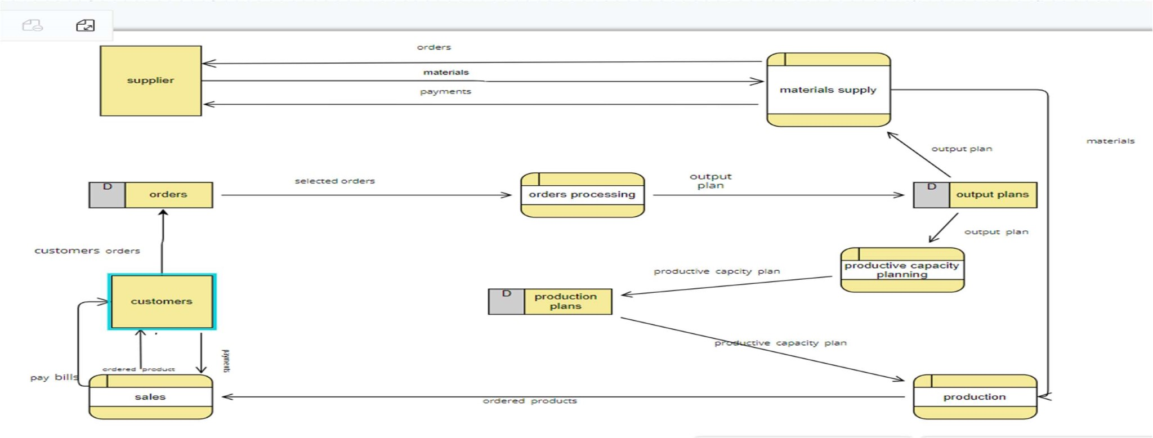

DATA FLOW DIAGRAM FOR GLOBAL SALES DATA ANALYTICS:

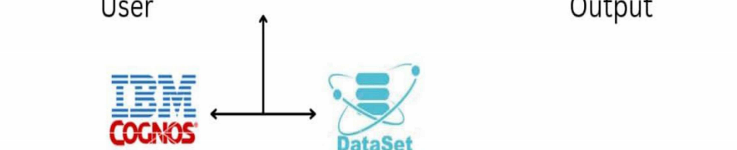

FLOW STRUCTURES :

1.user configures credentials for the Watson natural language understanding service and starts the app.

1. user selects data files to process and load.
2. apache tikan extracts text from the data file.

4.extracted text is passed to Watson NLU for enrichment.

5.enriched data is visualized in the UI using D3.js library.

User Stories

|  |  |  |  |  |  |  |
| --- | --- | --- | --- | --- | --- | --- |
| User Type | Functional  Requirement  (Epic) | User Story  Number | User Story / Task | Acceptance criteria | Priority | Release |
| Customer  (Mobile user) | Registration | USN-1 | As a user, I can register for the application by entering my email, password, and confirming my password. | I can access my account / dashboard | High | Sprint-1 |
|  |  | USN-2 | As a user, I will receive confirmation email once I have registered for the application | I can receive  confirmation email & click confirm | High | Sprint-1 |
|  |  | USN-3 | As a user, I can register for the application through Facebook | I can register & access the dashboard with Facebook Login | Low | Sprint-2 |
|  |  | USN-4 | As a user, I can register for the application through Gmail |  | Medium | Sprint-1 |
|  | Login | USN-5 | As a user, I can log into the application by entering email & password |  | High | Sprint-1 |
|  | Dashboard | USN-6 | As a user,I can create the visualization by using the dashboard In the application |  | High | Sprint-3 |
| Customer (Web user) | Login | USN-1 | As a user,I can register for the application by entering my email ,password and confirming my password | I can access my account and dashboard | High | Sprint-1 |
| User Type | Functional  Requirement  (Epic) | User Story  Number | User Story / Task | Acceptance criteria | Priority | Release |
| Customer Care Executive | Chat box | USN-1 | It can be used by easily access and responsible . | I can access by easily through application | High | Sprint-2 |
| Administrator | Calling | USN-2 | It can be used by easily access and responsible. | I can access by easily through application | High | Sprint-2 |
|  | Mail | USN-3 | It can be used by easily access and responsible | I can access by easily through application | High | Sprint-1 |